Statewide Park and Trail Research - Summary

A joint research project between Minnesota Department of Natural Resources, Greater Minnesota Regional Parks and Trails Commission, and Metropolitan Council | 2023-08-30

Table of Contents

# 1 Introduction

This summary report provides a high-level overview of the Statewide Park and Trail research project. The content of this report is duplicated in an [online, interactive website](https://minnesota-parks-and-trails-metrocouncil.hub.arcgis.com/).

Other deliverables from this project include data summaries (spreadsheets), unit-level fact sheets for each park and trail (pngs), a complete technical report on methods and findings (text document), and the code used to access and process all data (R scripts). All documents are accessible via the interactive website.

This project was funded with Legacy Partnership Research Funds from the State of Minnesota Parks and Trails Legacy Fund. The joint research project was conducted in collaboration with the Greater Minnesota Regional Parks and Trails Commission, the Metropolitan Council Regional Parks and Trails System, and the Minnesota Department of Natural Resources. We thank staff from across the different organizations and cooperating implementing agencies for their cooperation in sharing data and providing feedback.

# 2 Overview

Understanding visitation to Minnesota’s parks and trails is essential for planning, programming, and investment decisions. Visitation estimates generally rely on methods such as intercept surveys, in-field visitation counts, and automated trail counters. Visitation estimates using passively generated data sources may offer opportunities to complement existing strategies.

This project used aggregated and anonymized location-based services (LBS) data to estimate and evaluate visitation to Minnesota parks and trails. LBS data gives information about when and where people travel. This approach provides unprecedented detail about how visitors use parks and trails and broadly describes who those visitors are. Visitation and use patterns can be analyzed at annual, monthly, weekly, and hourly time intervals. This data makes it possible to understand how people travel to parks and trails and where they are coming from. This data is intended to supplement, but not replace existing data used for decision making.

## 2.1 Parks and trails are valuable

Most broadly, this research highlighted the incredible value of Minnesota’s parks and trails. We analyzed 202 parks and 177 trails (2,660) miles of trail). During the study period (January 2019 - April 2022), we estimate 175.98 million park visits and 234.1 million miles of trail use (Figure 2.1). If equally distributed across Minnesota’s [5.7 million residents](https://mn.gov/admin/demography/data-by-topic/population-data/our-estimates/), the average Minnesotan would have made 31 visits to parks and traveled over 41 miles of trail during this period. Park and trail use was highest in 2020, and there was an overall trend of increasing use over time.

Despite cold winters, Minnesota parks and trails are used year-round. Year-round visitation is supported by seasonal amenities, from swimming beaches to ski slopes and many others. Use in all seasons underscores the value of parks and trails.

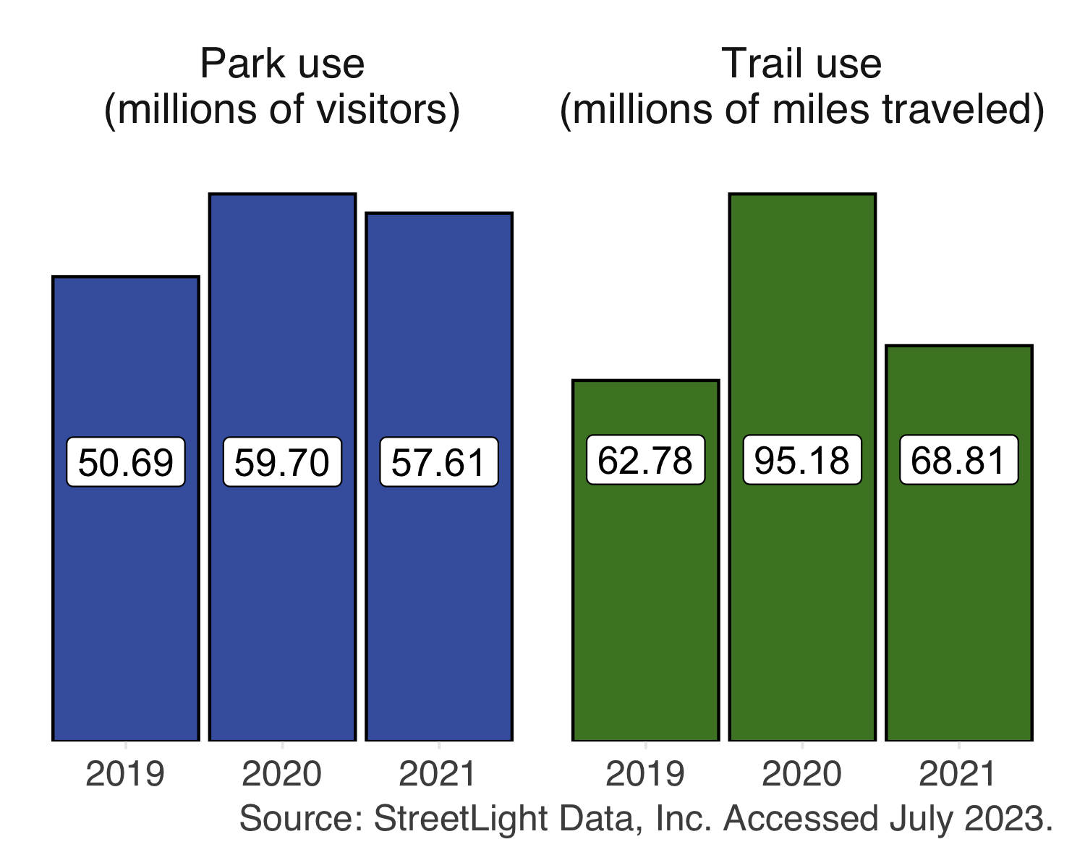

Figure 2.1: Summation of state and regional park and trail use across all three systems for the three complete years in this study (2019, 2020, 2021). This project additionally includes partial data for 2022.

## 2.2 State and regional systems have similarities and differences

This project evaluated a variety of parks and trails, from remote parks covering thousands of acres to bike trails passing through urban and residential centers (Figure 2.2). There are many similarities between the parks and trails analyzed. For example, they all draw visitors from beyond their immediate neighborhoods, and many share seasonal visitation patterns. However, this work also revealed substantial variation between parks and trails within each park system.

A more complete picture of the connections and similarities across systems emerges when considering park- or trail-level data. This detail means that findings aren’t limited to broad, system-level generalizations. Instead, unique patterns can be explored for each unit to better understand the entire statewide network of parks and trails.

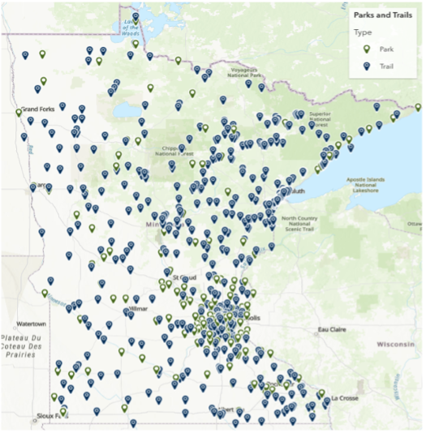

Figure 2.2: Park and trail locations included within this research. To be included, parks and trails must be eligible to receive Legacy funding. Source: Minnesota Great Outdoors.

## 2.3 Park and trail visitor demographics vary widely

Though we estimate high use of parks and trails across the state, the benefits accessible parks and trails are not equitably distributed among Minnesotans. Specific demographic patterns of visitors differ by individual units.

This project provides the opportunity to learn more about who visits parks and trails and to guide our work toward equitable park and trail access (Figure 2.3). Location-based services data can provide inferred demographics when survey data does not exist for race and ethnicity, education, and income categories. While inferred demographics are different than intercept surveyed responses and cannot capture visitors’ lived experiences, they may provide valuable insight. For example, the findings from this work may be used to guide future outreach or survey efforts.

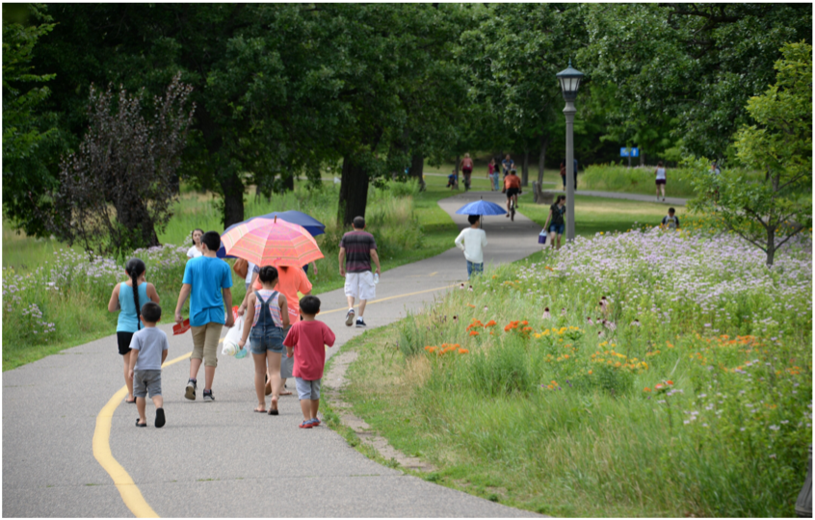

Figure 2.3: Reducing barriers to access and ensuring that all Minnesotans benefit from parks and trails across the state is important.

# 3 Parks

Understanding park visitation is essential for planning, programming, and investment decisions. This project used location-based services (LBS) data to analyze weekly use of 202 state and regional parks across Minnesota from January 2019 - April 2022. This data is intended to supplement, but not replace existing data used for decision making. Approximately 175.98 million park visits occurred across all parks during the study period. In total, 2020 had the highest use across the years analyzed. We found that parks were used in all seasons, although the summer months of June, July, and August had the highest use. Most visitors traveled to parks in vehicles, but this analysis also considered people arriving on bike or foot. Weekly-level detail revealed considerable variation in use patterns across and within individual park units.

## 3.1 Methods

Aggregated and anonymized LBS data was used to estimate weekly use of 202 state and regional parks across three systems (n = 78 Minnesota Department of Natural Resources parks (DNR State), n = 57 Greater Minnesota Regional Parks and Trails Commission parks (Greater MN Regional; 43 designated and 14 eligible for designation), and n = 67 Twin Cities metropolitan regional parks (Metro Regional)). The resulting data set consists of 173 weekly observations for each park. Each observation reports estimated weekly use disaggregated by travel mode (vehicle, bicycle, and pedestrian).

Geographic boundaries used to measure park use were accessed via the Minnesota Geospatial Commons for [DNR State](https://gisdata.mn.gov/dataset/bdry-dnr-lrs-prk) and [Metro Regional systems](https://gisdata.mn.gov/dataset/us-mn-state-metc-plan-parks-regional). Greater MN Regional park geographies were obtained via personal communication with Renee Mattson (Executive Director, Greater Minnesota Regional Parks and Trails Commission). In all cases, park geographies were post-processed to optimize suitability for LBS analyses. Specifically, geographies were reviewed to ensure all amenities, trailheads, beaches, and parking lots were included but that unrelated parking lots, transverse roads, or other activity centers were removed. Post-processing also incorporated unit-specific feedback requested throughout the project.

Total park use was estimated by summing the number of visitors entering a park via vehicle, bicycle, or foot. The LBS data provider does not explicitly measure visitors arriving by other transportation modes, but other modes (i.e., snowmobiles, boaters) may be captured and classified as either vehicle, bike or foot visitors by the LBS data provider using their probabilistic models. A park visitor must have remained within the park boundary for at least five minutes to be counted. Visitors were counted once upon each park entry (i.e., overnight campers making a day trip outside the park would be counted upon their return as well as initial entry but visitors making multiple stops or short trips within the park are only counted upon initial entry).

LBS data was obtained from StreetLight Data, Inc. and last accessed in April 2023. The StreetLight application programming interface was used to run a zone activity analysis for each park’s vehicle, bike, and pedestrian counts during each week of the study period (104,838 unique analyses for parks). Vehicle multipliers representing the average number of persons per vehicle were applied to convert vehicle counts to visitor counts. Devices registered to minors (under age 18) are not included in the LBS data source, however vehicle multipliers include visitors of all ages.

### 3.1.1 Data validation

Existing use estimates were used to validate LBS estimates. For example, the DNR generates park-level use estimates based on vehicle counters, permit sales, and vehicle multipliers. Because the estimates are generated using different data sources and methods, some discrepancies are expected. However, the overall agreement between DNR and LBS estimates is high (r = 0.87, p = < 0.001) and confirms that LBS data generates reasonable estimates of park use. Full data validation and methodology is available in the technical documentation.

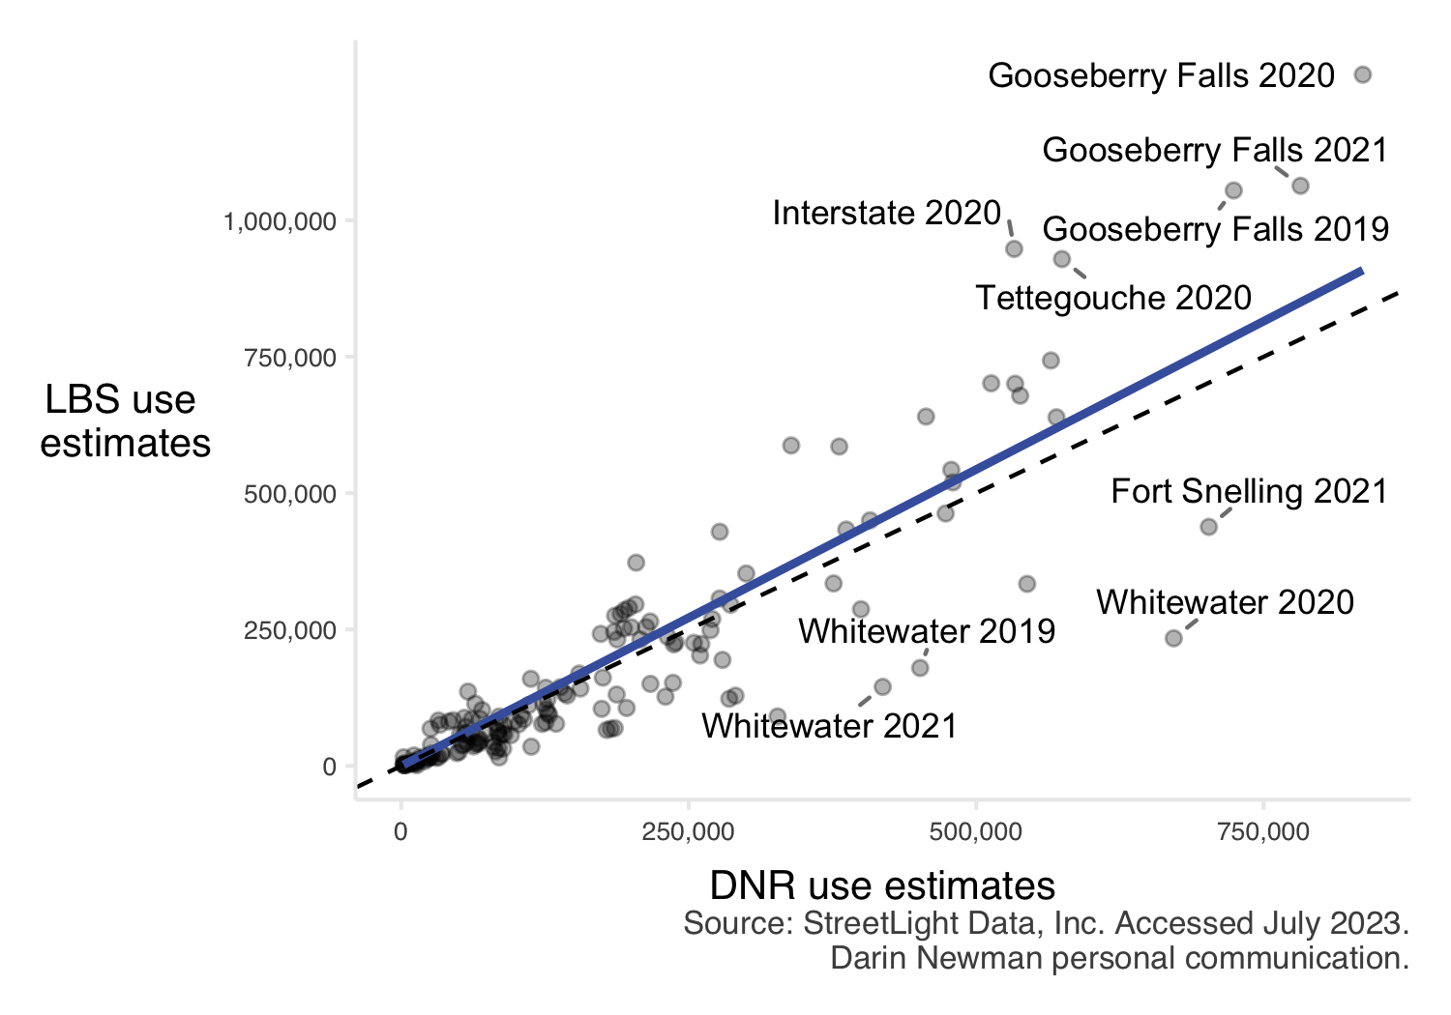

Figure 3.1: Comparison of DNR and LBS use estimates at state parks. Annual measurements of 2019 and 2020 were compared, as well as the first six months of 2021. The dashed line indicates a perfect one-to-one relationship; the solid blue line indicates the line of best fit. LBS estimates tend to be slightly higher than existing DNR estimates. Parks with the largest discrepancies are labeled.

## 3.2 Park use increased in 2020

In total, 2020 had the highest park use across the years analyzed (59.7 total million visitors across three systems compared to 50.69 and 57.61 million visitors in 2019 and 2021, respectively). In many cases, the COVID-19 pandemic encouraged the use of Minnesota’s outdoor spaces as other indoor social and recreational opportunities were limited. While pandemic-related effects on park visitation varied across and within systems (Figure 3.2), the state park system saw the greatest overall increase in 2020. Both regional park systems (Greater MN Regional and Metro Regional) saw more modest increases from 2019 to 2020, with visitation remaining high into 2021.

At the unit level, not all parks saw increased use in 2020. While 128 units saw their highest use in 2020, 25 units had their highest use in 2019 and another 49 had the highest use in 2021. Closures of campgrounds, beaches, or other amenities to facilitate social distancing often characterized units with lower use in 2020.

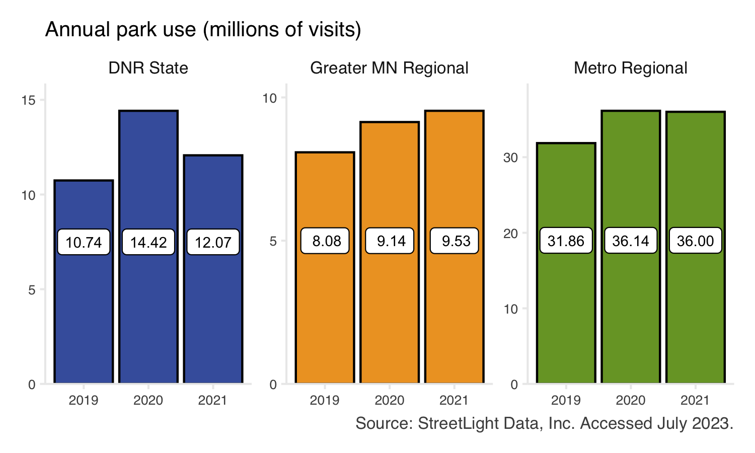

Figure 3.2: Total estimated park use. Bars show the system-wide total visits to parks across the three complete years in this study (2019, 2020, 2021). Bar color indicates park system. The number of parks varies by system (DNR State = 79, Greater MN Regional = 57, Metro Regional = 67), and individual park units may show annual visitation trends which differ from the overall system trend.

## 3.3 Weekly data shows nuanced use patterns

At individual park units, weekly LBS estimates can identify relatively precise changes in use. The data often reflect special events, extreme weather, and management changes. This temporal granularity may assist in evaluating park planning and management decisions.

For instance, some units closed facilities during the spring and summer of 2020 to facilitate social distancing (e.g., Spirit Mountain Recreation Area (Greater MN Regional) closed mountain biking facilities). The associated drop in park use is clear in a weekly time series; more generalized annual or monthly summaries may have otherwise obscured this causal relationship. Additionally, some special events cause notable increases in use, which can also be observed in a weekly time series (e.g., Nokomis Hiawatha Regional Park (Metro Regional) hosts US pond hockey championships every winter).

Detailed use data for individual park units can be explored in the interactive below (Figure 3.3). Select a unit of interest using the drop-down menu, and hover over the plot to view detailed information about use. If desired, click and drag on the plot to zoom in.

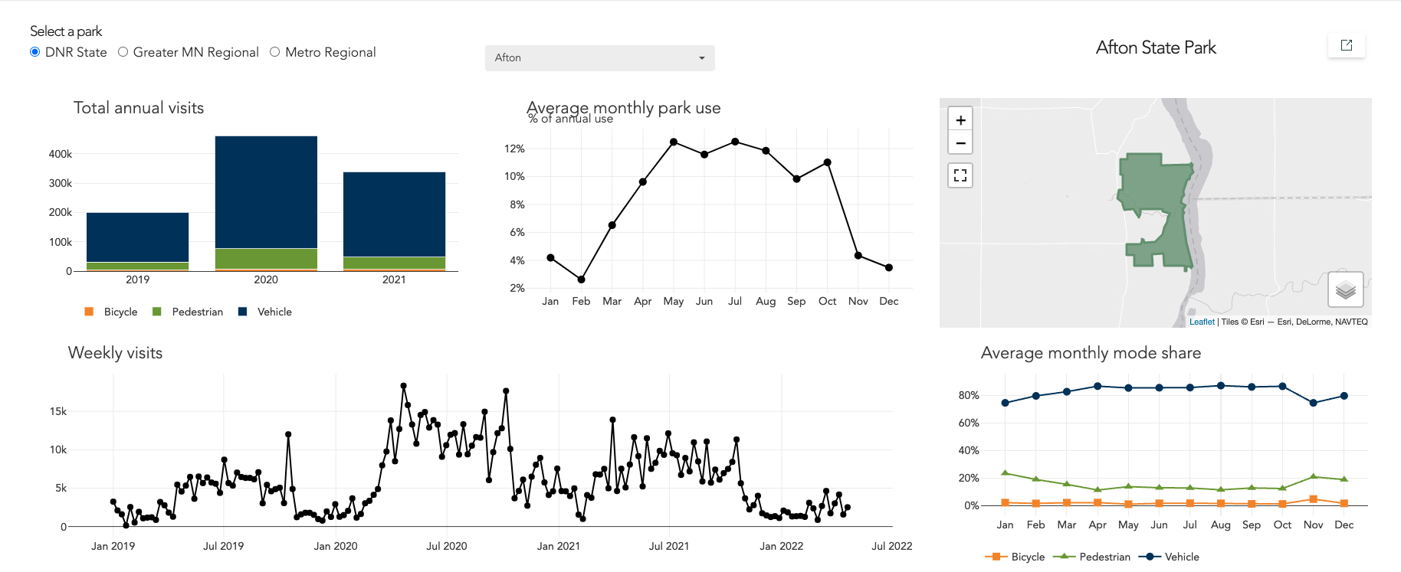

Figure 3.3: Screenshot of the dashboard which is embedded within the interactive report. The dashboard contains interactive elements showing a timeseries of weekly park use and mode share. A summary table of use for the three complete years in this study is also included, and an outline map of the park location.

## 3.4 Parks are used in all seasons

Our data shows that Minnesota’s parks are well-used in all seasons. At the system level, the summer months of June, July, and August consistently had the highest use; however, there is substantial “off-peak” park use (Figure 3.4).

At the park level, strong seasonal patterns generally indicate the presence of season-specific amenities such as ski facilities or beaches. For instance, two parks saw the majority (> 50%) of 2021 use occur during the winter months of December, January, and February. Both Detroit Mountain Recreation Area (Greater MN Regional, 58.3% winter use) and Hyland-Bush-Anderson Lakes, Three Rivers (Metro Regional, 53.6% winter use) have downhill skiing facilities. There were 40 parks that saw the majority of their annual visitation occur during the summer and no parks that had the majority of visits during the spring or fall. Most parks (159) did not see the majority of annual visitation occur within a single season.

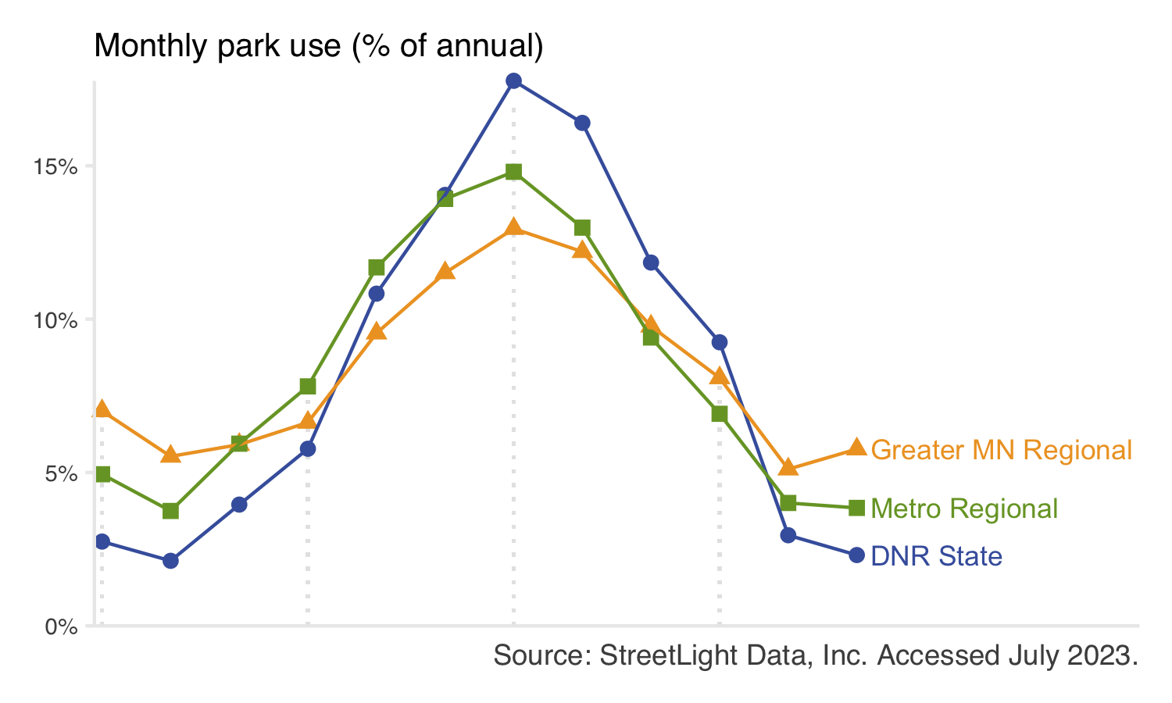

Figure 3.4: Monthly park use as a percent of total annual use for each system. Points show the average monthly use across the three complete years in this study (2019, 2020, 2021). Point color indicates park system. Individual park units may show trends that differ from the overall system trend.

## 3.5 Hourly park use varies by day and system

On weekends (Sa-Su), all parks showed a midday peak in use (Figure 3.5). On weekdays (M-F), this same midday peak is observed for DNR state parks. Regional parks, however, had a pronounced “after work” peak beginning around 5:00 pm.

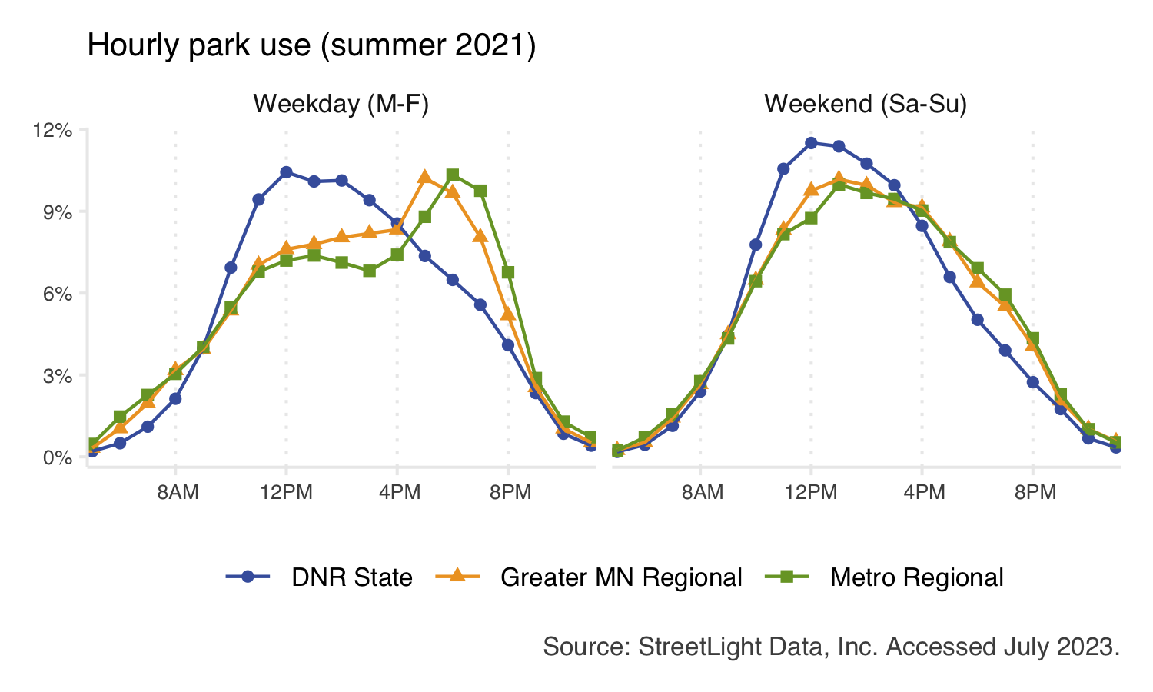

Figure 3.5: Daily use patterns during summer 2021 for each system. For each system, the total number of visits across all parks is summed, from which the percent of total visits is calculated. Individual park units may show trends that differ from the overall system trend.

## 3.6 Most visitors drive to parks

Our analysis includes estimated counts of visitors arriving at parks by vehicle, bicycle, or on foot (pedestrian). This “mode share” data provides nuance and can help characterize parks. For example, while most visitors traveled to parks in vehicles, the state park system had the highest vehicle mode share (Figure 3.6). Regional park systems had a larger portion of bicyclist and pedestrian visitors. The mode share of park visitors was relatively stable across different seasons.

At individual park units, mode share information may be helpful in identifying infrastructure improvements. For example, additional bike storage may be needed at state parks with high bicycle mode share. A regional park with low pedestrian mode share in an otherwise walkable area may indicate barriers to access (e.g., fenced areas or roads without crosswalks or bridges, or lack of links to public transit). Such park-level analyses are beyond the scope of this project, but may prove valuable in future work.

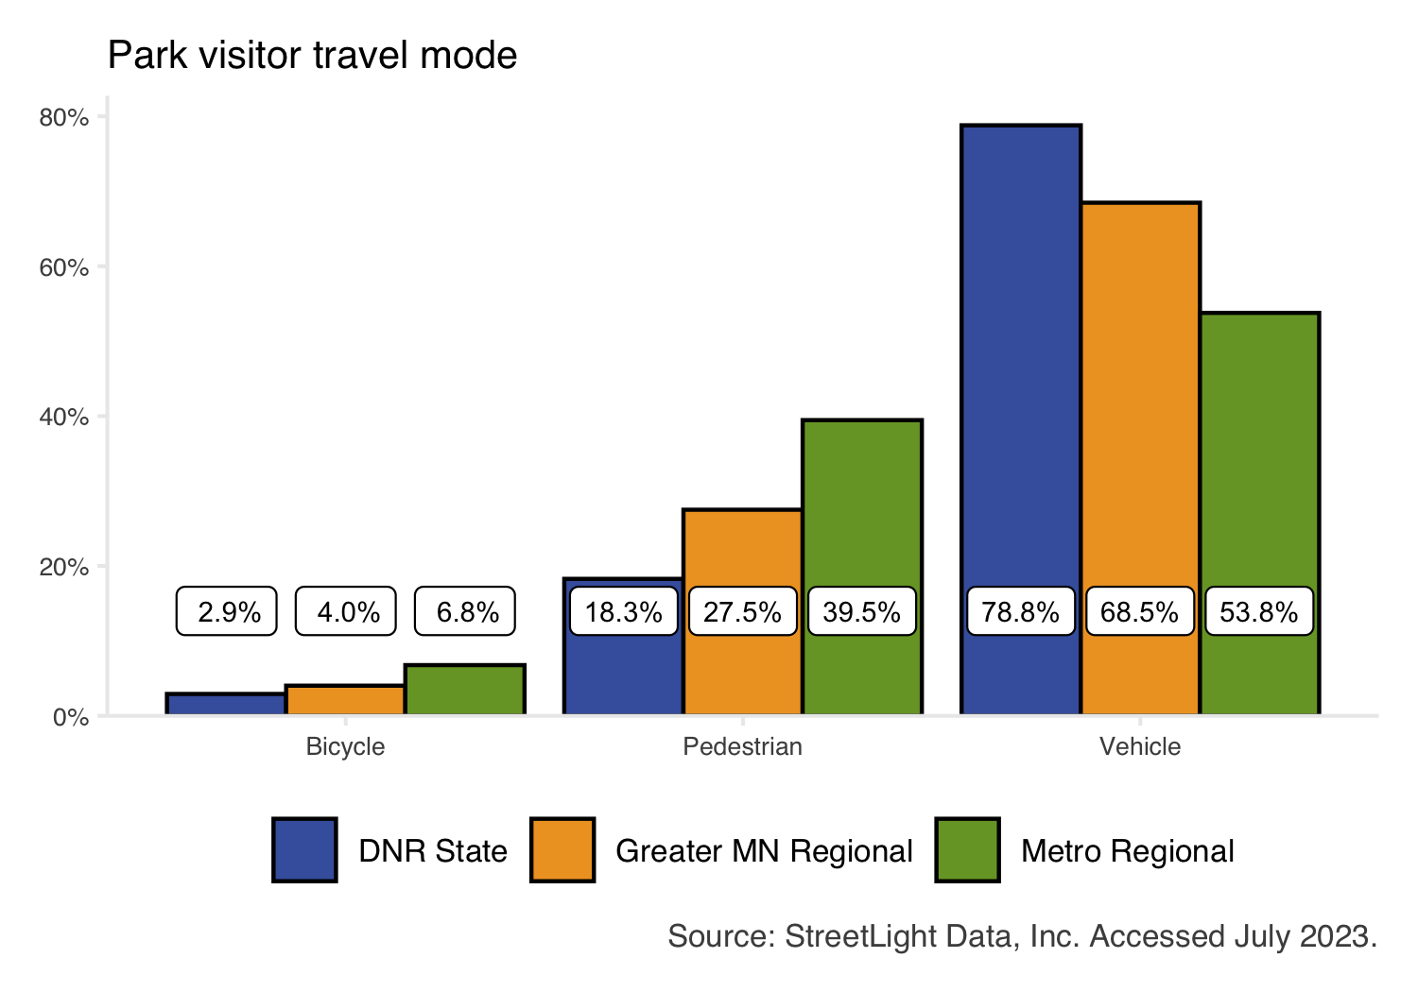

Figure 3.6: Mode share of trips made to parks. Bars show the average annual mode share across the three complete years in this study (2019, 2020, 2021). Bar color indicates park system. Individual park units may show trends that differ from the overall system trend.

# 4 Trails

Understanding trail visitation is essential for planning, programming, and investment decisions. This project used location-based services (LBS) data to analyze monthly visitation to 177 state and regional trails across Minnesota from January 2019 - April 2022. This data is intended to supplement, but not replace existing data used for decision making. Approximately 234.1 million trail miles were traveled by visitors during the study period. In total, 2020 had the highest use across the years analyzed. Bicyclists made up the majority of trail use, although pedestrians made up a larger portion of use on urban trail segments and during winter months. There was considerable variation in use across segments of the same trail.

## 4.1 Methods

Aggregated and anonymized LBS data was used to estimate weekly visitation to state and regional trails across three systems. Theoretically, the concept for measuring trail use is identical for physical trail counters (e.g., infrared or pneumatic tubes) and LBS methods. Both rely on “gates” through which visitors pass. With trail counter approaches, “gates” are physical sensors on trails. LBS data detects users passing through non-physical geographic gates. This theoretical alignment means that neither approach can identify the number of unique visitors along a trail’s entire length. For instance, visitors who do “out-and-back” trips will be counted twice (passing through the same gate once in each direction).

Geographic data used to measure trail use was obtained from each agency. Minnesota Department of Natural Resources ([DNR State](https://gisdata.mn.gov/dataset/trans-state-trails-minnesota)) and Twin Cities metropolitan regional trails ([Metro Regional](https://gisdata.mn.gov/dataset/us-mn-state-metc-trans-regional-trails-exst-plan)) were accessed from the Minnesota Geospatial Data Commons on 18 October 2022. Greater Minnesota Regional Parks and Trails Commission (Greater MN Regional) trail files were obtained via ArcGIS Online in November 2022. Trails were decomposed into [OpenStreetMap](https://www.openstreetmap.org/about) (OSM) trail segments (Figure 4.1). OSM is a widely-used mapping service used by StreetLight (the LBS data provider), private companies (i.e., Amazon, Apple, Microsoft, ESRI), and government sectors around the world. Each trail typically consists of multiple segments split by roads or other intersecting trails/paths; however, it was beyond the scope of this project to edit or customize OSM trail segments. Trail segments less than 50 feet were removed from the analysis. This analysis contains 177 unique trails with 3,934 distinct trail segments totaling over 2,660 miles (Table 4.1). Both paved and unpaved trails are represented in the data.

LBS data was used to measure trail use along each of these standardized trail segments. Bicycle and pedestrian use is considered. The LBS data provider does not explicitly measure trail visitors arriving by other transportation modes, but other modes (i.e., snowmobiles, equestrians, skiers) may be captured and classified as either bikers or walkers by the LBS data provider using their probabilistic models. Segment-level LBS estimates of trail use are conceptually identical to estimates generated by one trail counter per segment. At the trail level, we report total trail miles traveled, which is the estimated count of trail users multiplied by the length of the trail segment being used. When summed at the trail level, this produces a single, robust estimate of trail use. The estimated count of trail users, which is a metric analogous to a trail counter estimate, is available for each segment.

LBS data was obtained from StreetLight Data, Inc. and last accessed in April 2023. The StreetLight application programming interface was used to run a zone activity analysis for each trail segment’s bicycle and pedestrian use during each month of the study period (314,720 unique analyses for trails). Users who traveled along any trail segment for any distance or duration were counted; no stoppage time was necessary. Devices registered to minors (under age 18) are not included in the LBS data source.

|  |
| --- |
| Figure 4.1: Example of OSM segments at Camden Regional Trail (Greater MN). Each colored portion of the trail represents one OSM segment. |

Figure 4.1: Example of OSM segments at Camden Regional Trail (Greater MN). Each colored portion of the trail represents one OSM segment.

Table 4.1: Summary of unique trails, identified trail segments, and covered trail miles across the three systems.

| System | Trails | Segments | Miles |
| --- | --- | --- | --- |
| DNR State | 35 | 991 | 1,121 |
| Greater MN Regional | 57 | 897 | 950 |
| Metro Regional | 85 | 2,046 | 589 |

## [1] "/Users/rotenle/Documents/MetC_Locals/CD/legacy-LBS-parktrail-research/figures/storymap/trail-summary-table.png"

### 4.1.1 Data validation

Physical trail counter estimates were used to validate LBS estimates. For example, Greater Minnesota conducted several studies of mountain bike use on regional trails during the summer of 2021 (Figure 4.2). Short-term trail counters (i.e., counters placed for less than one month) were excluded from validation because LBS data is only available at monthly increments. Because the estimates are generated using different data sources and methods, some discrepancies are expected. Data was also validated against Minnesota Department of Transportation bicycle and pedestrian counters; please see technical documentation for additional detail.

While estimates of trail users passing through trails counters or geographic “gates” offer reasonable use estimates for individual trail segments, trail miles traveled is preferred as a robust measurement of trail-level use as described in the Methods. To build confidence in the trail miles traveled metric, we compared annual trail miles traveled (user count × segment length) to the annual count of users at the most used segment of each trail (representing a hypothetical location for a single trail counter). On average, we found that 2.5 trail miles are traveled for every user counted at the most used segment; please see the technical documentation for further validation detail.

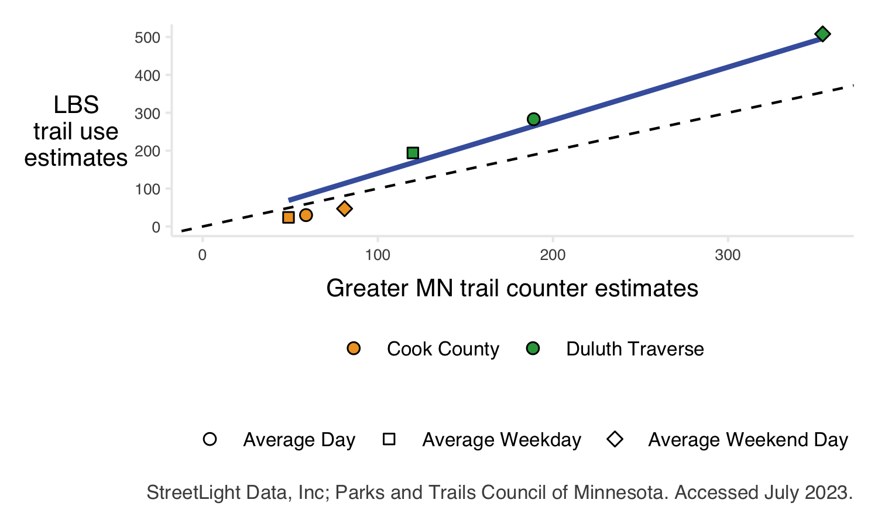

Figure 4.2: Comparison of Greater MN trail counter estimates and LBS estimates at long-term trail counter sites. The dashed line indicates a perfect one-to-one relationship; the solid blue line indicates the line of best fit. LBS estimates tend to be slightly higher than existing estimates.

### 4.1.2 Trail use increased in 2020

Across the state, 2020 saw a distinct increase in trail use (95.18 million trail miles traveled in 2020 across three systems compared to 62.78 and 68.81 million miles traveled in 2019 and 2021, respectively). This increase was likely driven by behavior changes caused by the COVID-19 pandemic. Trail use in 2021 largely returned to pre-pandemic levels, though use was higher in 2021 than 2019. The three systems saw proportionally similar changes in trail use.

At the unit level, not all trails had increased use in 2020. Year 2020 had the highest use for 130 trail units, but 22 and 25 units had the highest use in years 2019 and 2021, respectively.

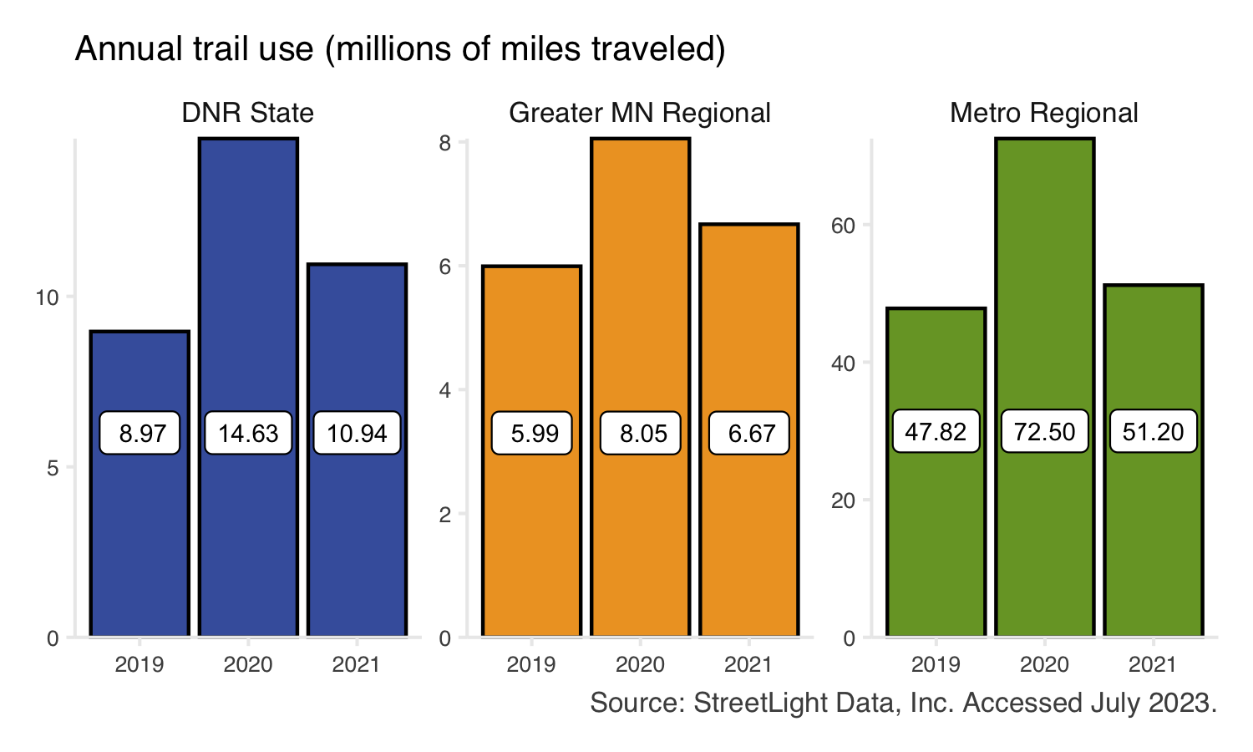

Figure 4.3: Total estimated trail use (trail miles traveled) by year. Bars show the system-wide total trail use across the three complete years in this study (2019, 2020, 2021). Bar color indicates trail system. Individual trail units may show annual visitation trends that differ from the overall system trend.

### 4.1.3 Segment-level data provides detailed insight

Trails connect Minnesotans to a wide range of land uses, essential services, cities, and other attractions. In addition to the recreation value of trails, trails are essential components of transportation networks, connect park systems, and advance natural resource conservation efforts across the state. Due to the variety of landscapes and diverse services trails provide, not all segments of trails are used equally.

While trail use estimates are often limited to several short-term trail counters sited in strategic locations, LBS methods can estimate use across a trail’s entire length and reveal spatial and temporal variation in trail use.

For example, consider a trail with several temporary closures along its length (e.g., portions of Cedar Lake Regional Trail (Metro Regional) closed in May 2019 for light rail construction. A single trail counter might indicate unchanged trail use or trail use falling to zero, depending on the counter’s specific location (a single “gate”). Segment-level LBS estimates reflect changes to all trail segments – both those which see declines in visitation and those where visitation remains high – better reflecting on-the-ground conditions.

Similarly, trails that are primarily rural with some segments passing through population centers may have large differences between their most used trail segments (Central Lakes State Trail).

This data can be explored for each trail and trail segment. In the interactive figure below (Figure 4.4), select a trail of interest to see a time series of trail use from January 2019 - April 2022, a map of activity by trail segment, a time series of mode share, and a summary table. Hover over any element and/or zoom in for additional detail.

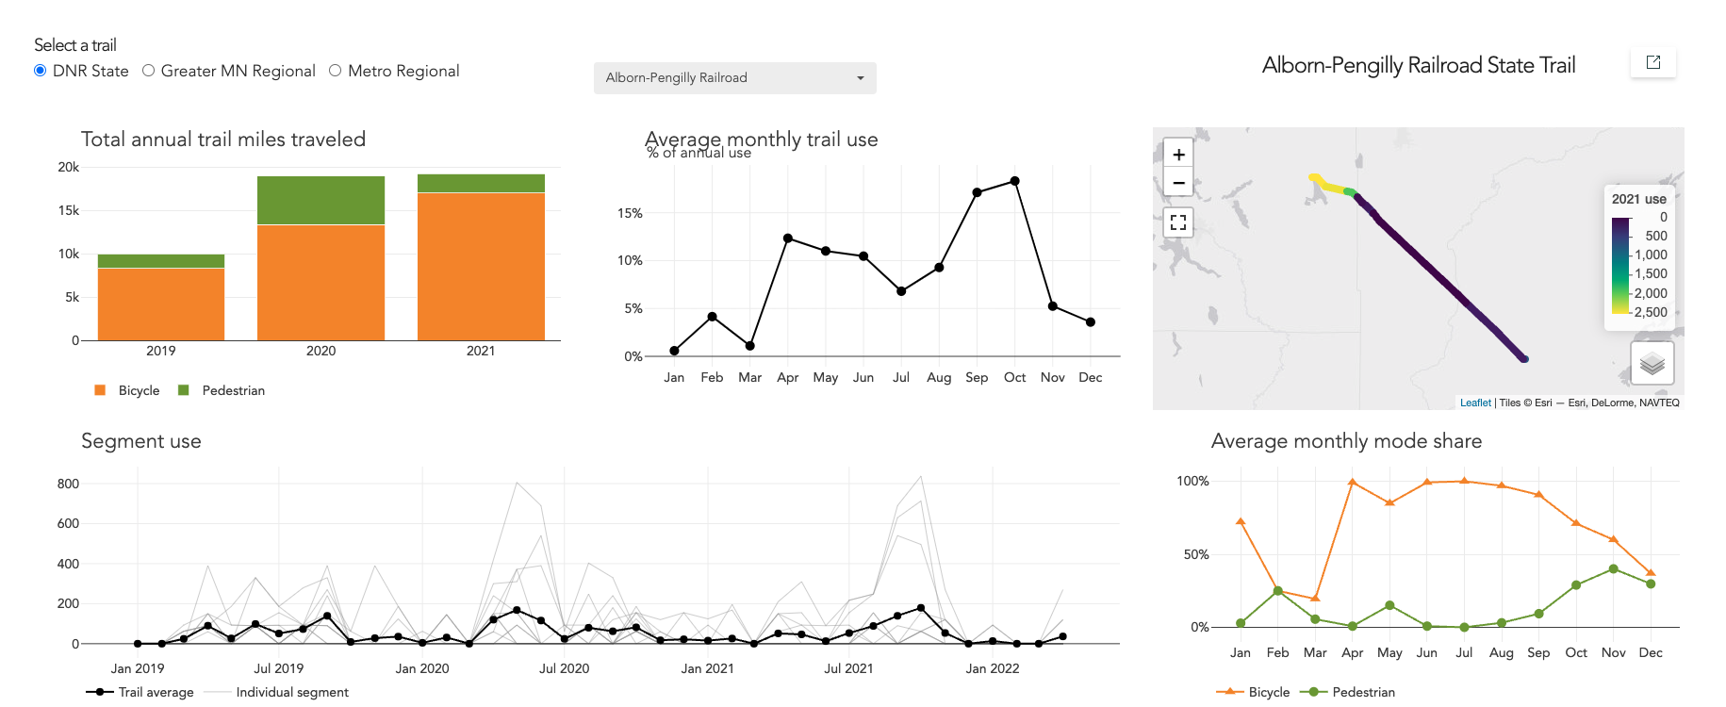

Figure 4.4: Screenshot of the dashboard which is embedded within the interactive report. The dashboard contains interactive elements showing a timeseries of monthly trail use and mode share. A summary table of use for the three complete years in this study is also included, and a map of the trail colored by segment-level use.

### 4.1.4 Trails are used in all seasons

Using LBS data to estimate trail use over a year shows that Minnesota’s trails are used in all seasons, although to a lesser extent than Minnesota’s parks. Trail use generally builds throughout the spring, peaks in the summer, and tapers off in the fall (Figure 4.5). At the trail level, many segments which retain usage into the winter are within population centers or maintained (plowed) during the winter (e.g., portions of Brown’s Creek State Trail), highlighting the year-round importance of trails to the transportation network and for recreation benefits.

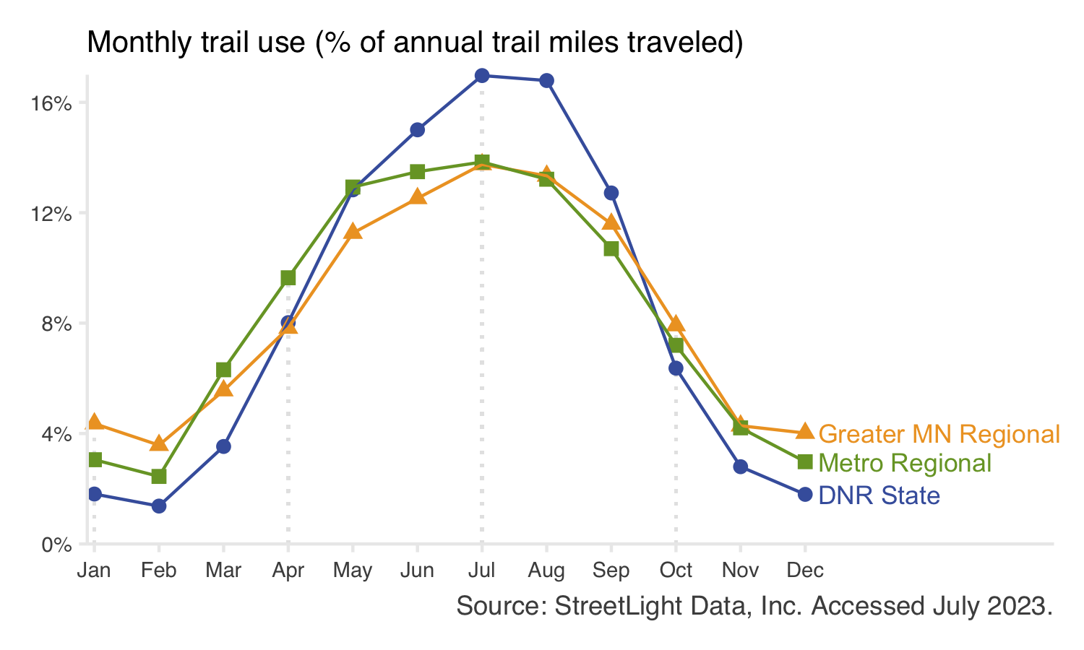

Figure 4.5: Monthly trail use as a percent of total annual use for each system. Points show the average monthly use across the three complete years in this study (2019, 2020, 2021). Point color indicates park system. Individual trail units may show trends that differ from the overall system trend.

### 4.1.5 Hourly trail use varies by day and system

On weekends (Sa-Su), trails tend to have a late morning peak in visitation around 11 a.m. (Figure 4.6). On weekdays (M-F), trail visitation shows a bimodal use pattern. A peak in the late morning to noon time frame is still observed. A second peak in use occurs around 5 p.m. The first peak (morning) is larger for DNR state trails, while the second peak (evenings) is larger for regional trails. The strength of the second peak may reflect commuting patterns (i.e., trails being used as transportation to and from work) or the ease of accessing regional trails near home after work.

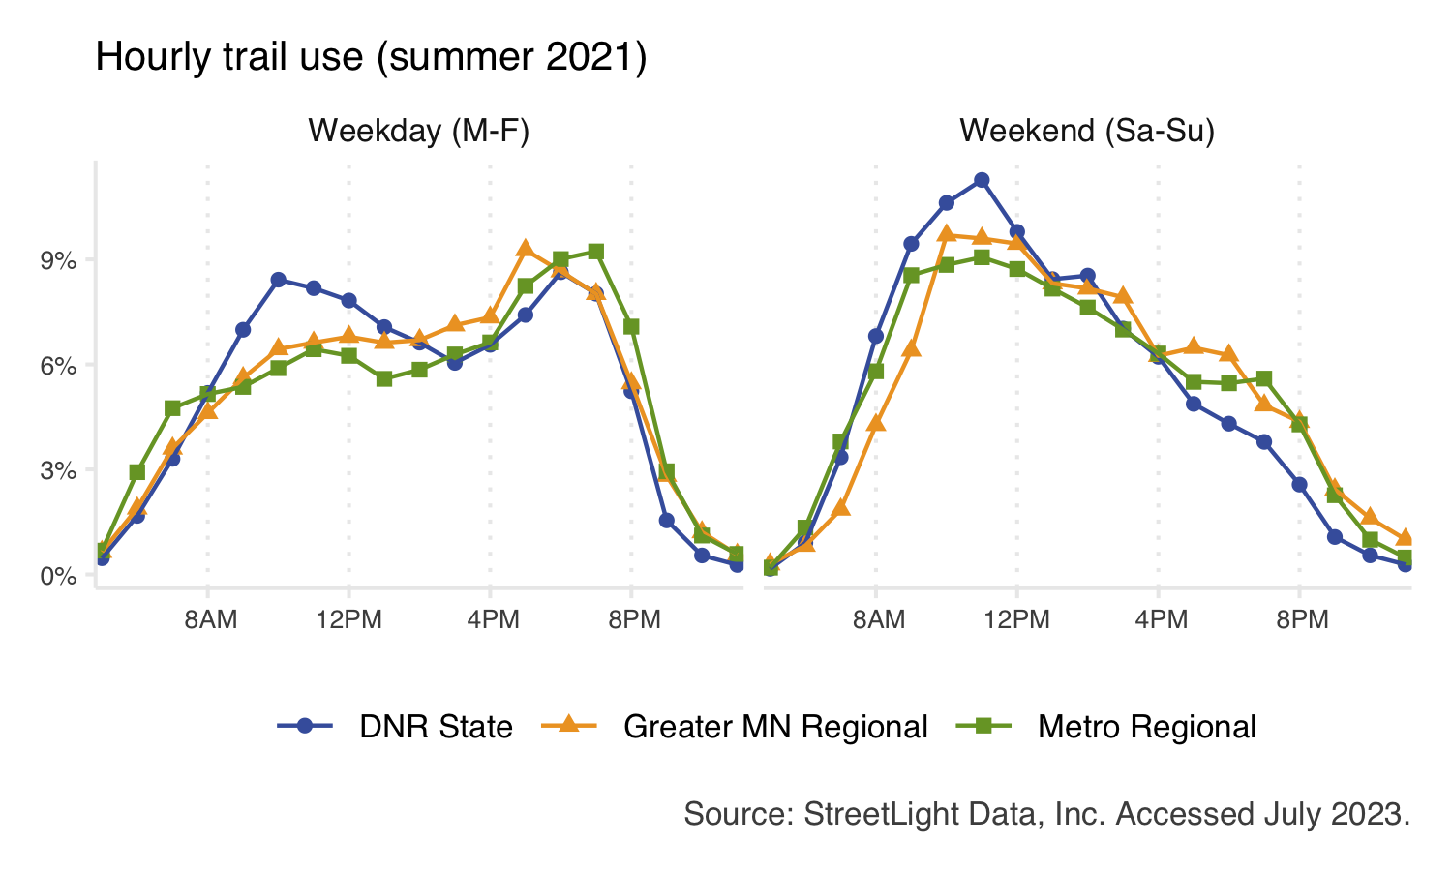

Figure 4.6: Daily trail use patterns during summer 2021 for each system. The total number of visits across all trails is summed for each system, from which the percent of total visits is calculated. Individual trail units may show trends that differ from the overall system trend.

## 4.2 Most trail users bike in the summer but walk in the winter

During summer months, bikers generally make up the majority of trail users (Figure 4.7). However, this pattern switches in the winter when pedestrians make up the majority of users. Trails that are maintained for winter mountain or fat tire biking see a less pronounced decline in bike use during winter months. This is most common for DNR state and Greater Minnesota regional trails.

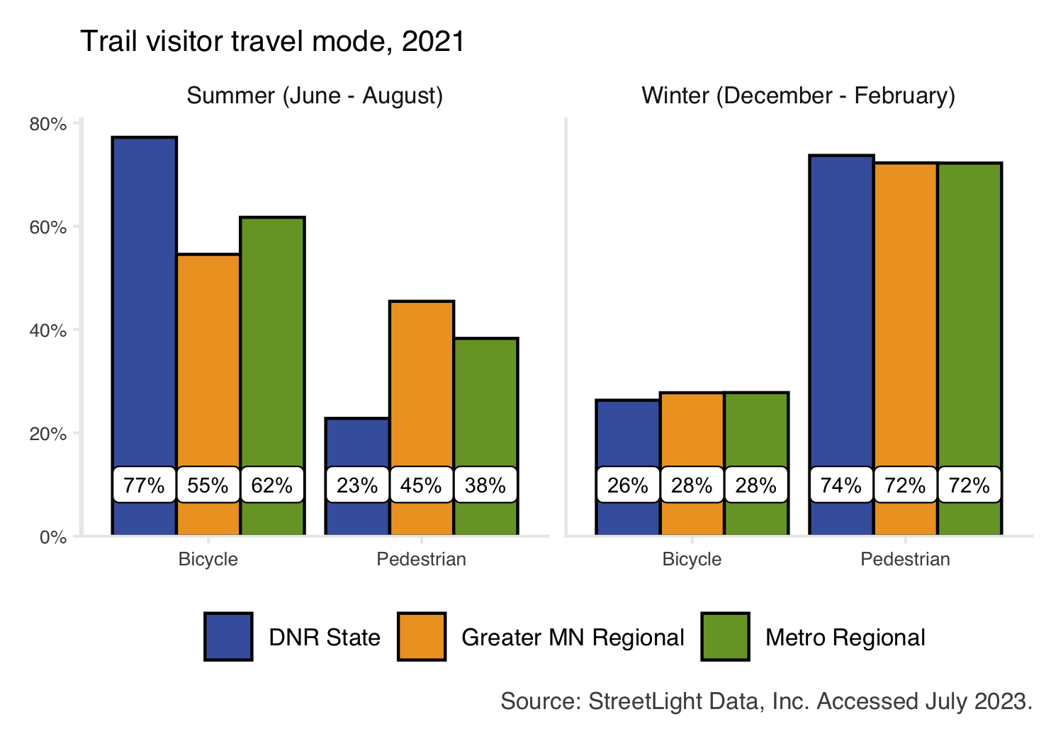

Figure 4.7: Mode share of trips made to trails in summer (June - August) and winter seasons (December - February). Bars show the average annual mode share across the three complete years in this study (2019, 2020, 2021). Bar color indicates trail system. Individual trail units may show trends that differ from the overall system trend.

# 5 Visitors

We found high use of parks and trails across the state. Most visitors live within Minnesota (90.96%), but we also found that Minnesota’s parks and trails attracted visitors from across the country. We found the benefits of accessible green space are not equitably distributed among Minnesotans, but the specifics of the visitation gap varied across systems and individual park and trail units. Understanding the demographic characteristics of visitors to Minnesota’s parks and trails can help reduce barriers to access and create more equitable access to parks and trails for all Minnesotans.

## 5.1 Methods

Aggregated and anonymized LBS data was used to infer park and trail visitor demographics. Inferred demographics from LBS data provide an opportunity to explore the demographics of park and trail visitors on a broad scale. Note that inferred demographics cannot and should not replace data about individuals’ lived experiences. Inferred data may be used to augment existing data or guide future research efforts, but should not be considered a replacement for intercept survey data.

To produce demographic estimates, the LBS data provider (StreetLight Data, Inc.) combines aggregated, anonymized GPS data with census information. StreetLight first assigns a home location to devices in their sample (i.e., smartphones) based on where devices “spend the night” most often. While StreetLight’s methods have nuance, generally if a device stays in a given location between 7 p.m. and 8 a.m., it’s home location is assigned to that census block group. Then demographic attributes are assigned to that device using a probability model based on the observed census demographics. The resulting data are distributed at coarser geographies (i.e., zip codes), and are always aggregated and anonymized. The data provided by StreetLight can never be used to identify individuals.

In this project, similar methods are used to process visitor demographics for parks and trails. For parks, demographics and home locations are collected for all visitors passing through the perimeter of the park. For trails, data is collected for any bicyclist or pedestrian passing through any section of the trail (i.e., trail segments are not used).

Inferred demographics are reported in three categories: race/ethnicity, educational attainment, and income. Visitor home locations are reported at the state level in this report; home locations are additionally available by zip code for individual parks and trails. Demographics are available for summer 2021.

### 5.1.1 Data validation

Inferred LBS visitor demographics were validated against the Metropolitan Council’s 2021 Park and Trail Visitor Survey. Data was compared at eight regional parks in the 7-county Twin Cities metropolitan area. A total of four education categories, seven income categories, and eight race categories were compared.

The alignment between surveyed and inferred visitor demographics is strong (Figure 5.1, Table 5.1). Across the eight parks, there are no significant differences between surveyed and inferred visitor income. Within education categories, LBS methods estimated more visitors with a high school or less educational attainment and fewer visitors with a graduate or professional degree. LBS data tends to estimate fewer white visitors than the intercept survey. Please see the technical documentation for further validation detail.

Table 5.1: Summary of validation between location based services derived demographic values and intercept survey values. Values show the number of parks with and without a statistically significant difference in demographic percentages at the 95% confidence interval.

| Attribute | Category | Not significantly different | Significant |
| --- | --- | --- | --- |
| Education | High school | 1 | 7 |
| Associate degree or some college | 7 | 1 |
| 4-year degree | 4 | 4 |
| Graduate or professional degree | 1 | 7 |
| Income | Less than $25,000 | 8 | 0 |
| $25,000 - 39,999 | 8 | 0 |
| $40,000 - 59,999 | 8 | 0 |
| $60,000 - 74/79,999 | 8 | 0 |
| $75/80,000 - 99,999 | 8 | 0 |
| $100,000 - 149,999 | 8 | 0 |
| $150,000 or higher | 8 | 0 |
| Race/ethnicity | American Indian | 8 | 0 |
| Asian | 8 | 0 |
| Black | 8 | 0 |
| Hispanic or Latinx | 8 | 0 |
| More than one race | 8 | 0 |
| Native Hawaiian and other Pacific Islander | 8 | 0 |
| Some other race | 8 | 0 |
| White | 1 | 7 |

## [1] "/Users/rotenle/Documents/MetC_Locals/CD/legacy-LBS-parktrail-research/figures/storymap/demographic-comparison-table.png"

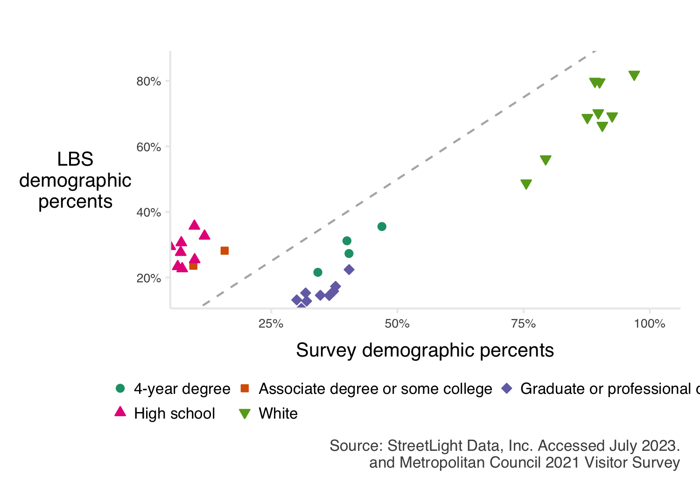

Figure 5.1: Comparison of location based services (LBS) demographic values against intercept survey values where there were significant differences in percentages at the 95% confidence interval. The dashed grey line shows a perfect one-to-one relationship.

## 5.2 Visitors from across the country visited Minnesota’s parks and trails

Visitors traveled to visit Minnesota’s parks and trails from all lower 48 states (Figure 5.2). Overall, Minnesota residents made up approximately 90.22% of users to parks and trails. Following Minnesota, adjacent states represent the largest portion of total use: Wisconsin with 3%, North Dakota with 0.83%, Iowa with 0.81%, and Illinois with 0.65%. Notably, California was the 5th most common home location (outside of Minnesota), representing 0.43% of total use.

While visits by international residents are counted in park and trail estimates, LBS data does not allow for identification of home locations for international residents.

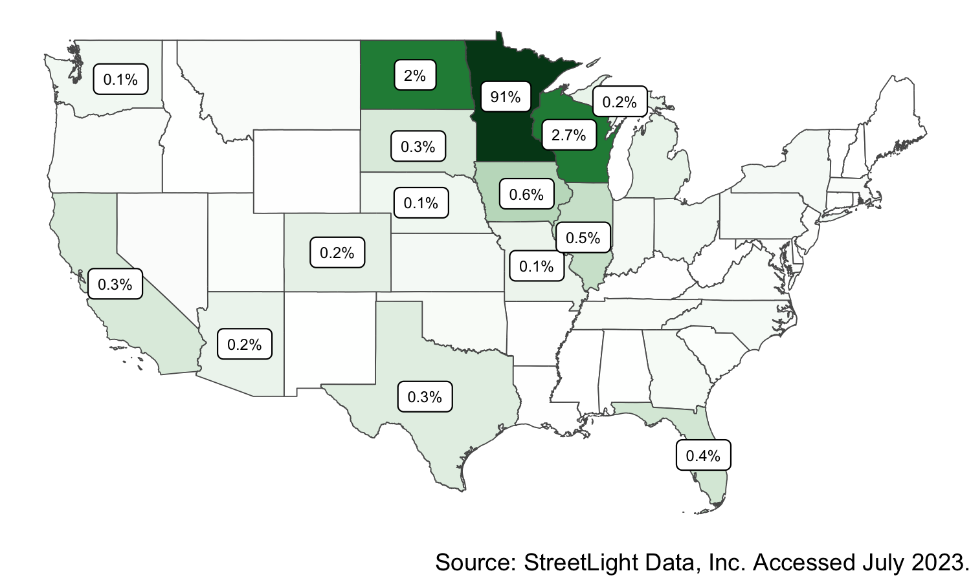

Figure 5.2: Proportion of visitors to Minnesota parks and trails in 2021 mapped by state of residence. Darker green colors indicate states with a greater share of visitors.

## 5.3 Park and trail visitor demographics vary widely

Park and trail users are not always representative of local or regional populations. We refer to this as a “visitation gap”, meaning that the use of parks and trails in Minnesota is not equitably distributed across the population. The extent of the visitation gap and specific dynamics vary across individual units and demographic categories (Figures 5.3, 5.4, 5.5).

Systems, and individual park and trail units, have unique missions and visitor populations. Equity analyses which compare LBS inferred demographics of park and trail users to baseline population demographics may be of interest but are recommended to be performed in a manner that is recognizes specific unit-level context. Therefore, it may be more appropriate to compare park and trail visitor demographics to local or regional demographics. Defining unit-specific reference populations is beyond the scope of this project, but park staff may be interested in using the spreadsheets produced from this project to compare visitor demographics with bespoke baseline populations.

## 5.4 Visitor attributes differ at the unit level

From visitor home locations to inferred demographics of visitors, a key finding of this work is that there is significant variation across parks and trails within a given system. This data can be explored individually for each unit.

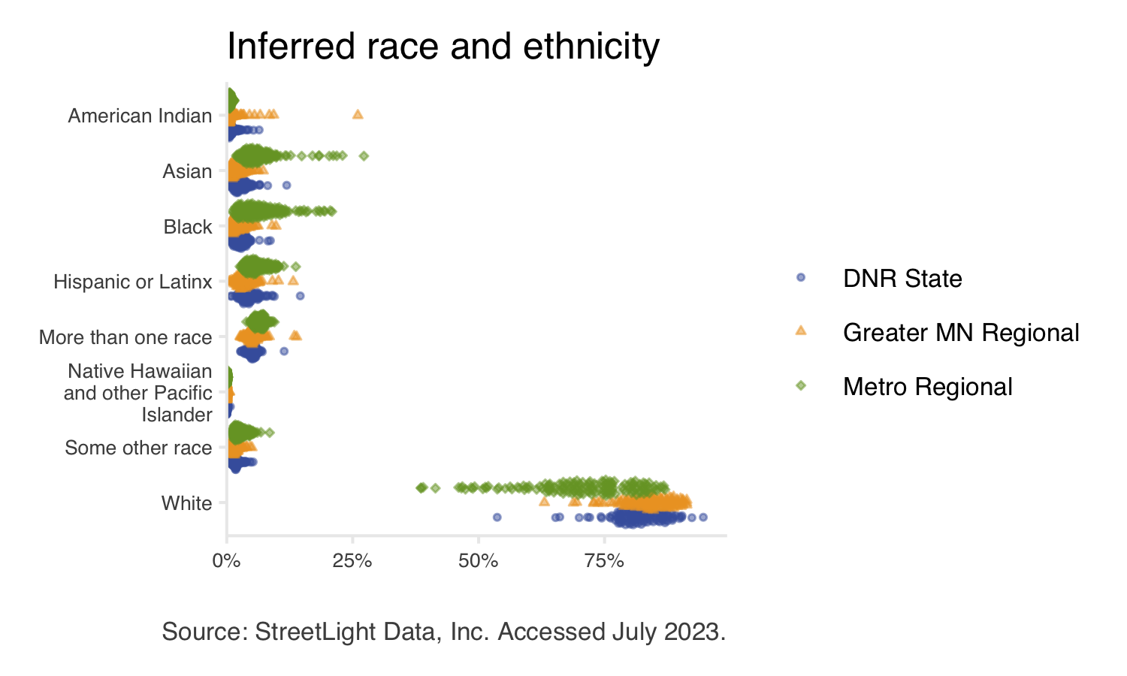

Figure 5.3: Inferred race and ethnicity of park and trail visitors. Each point represents a single park or trail. Point color and shape indicates system.

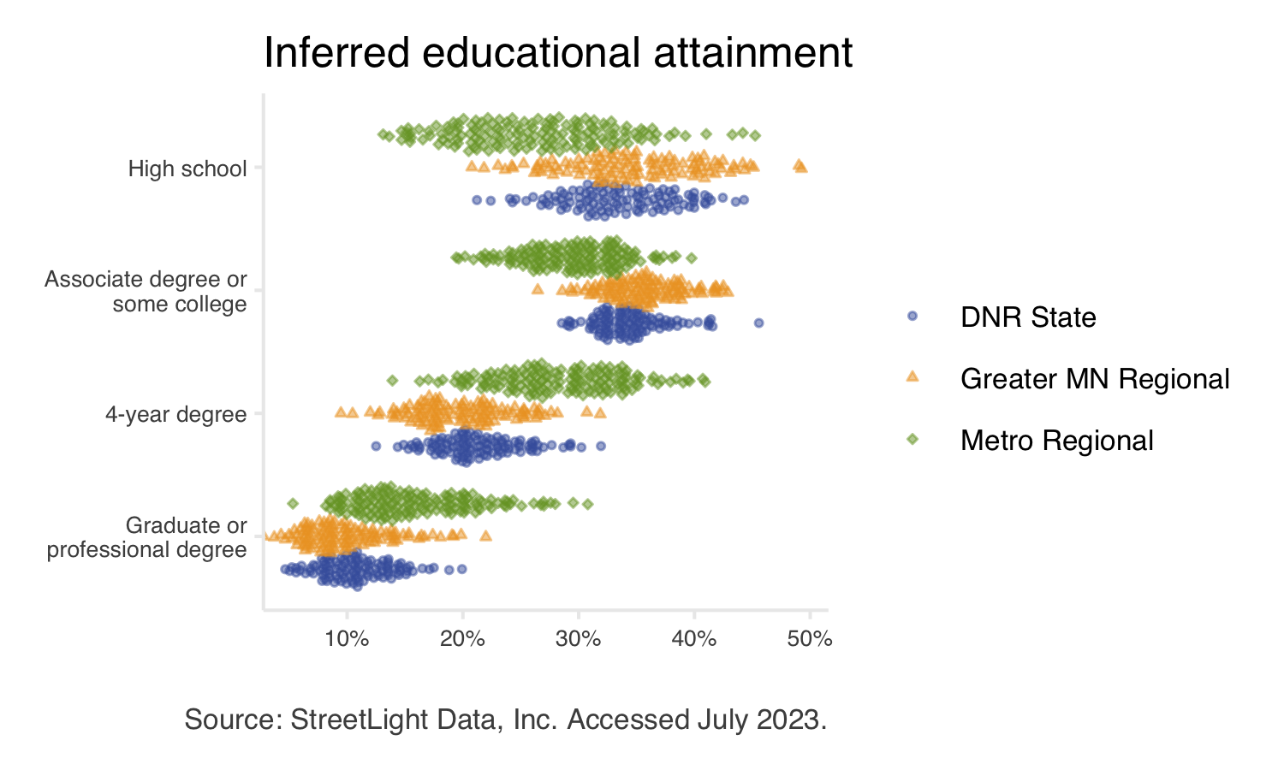

Figure 5.4: Inferred educational attainment of park and trail visitors. Each point represents a single park or trail. Point color and shape indicates system.

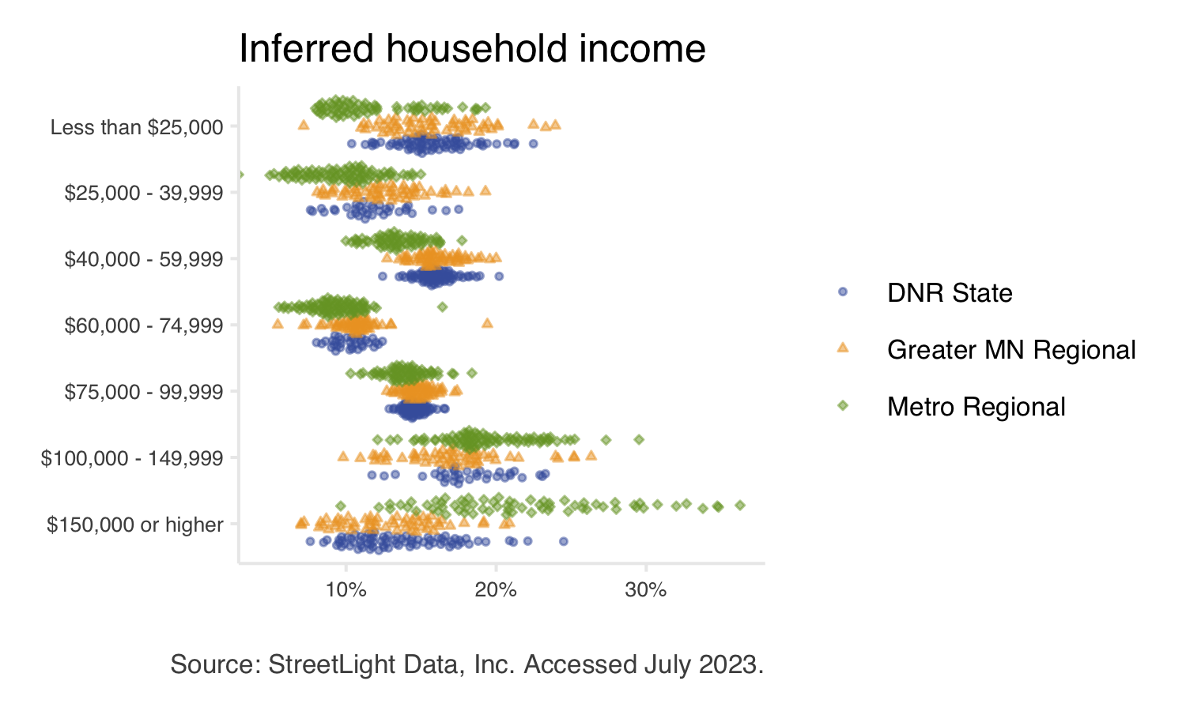

Figure 5.5: Inferred household income of park and trail visitors. Each point represents a single park or trail. Point color and shape indicates system.

# 6 Use Cases

This project aimed to develop universal methods of park and trail analysis. Therefore, in-depth analysis of individual units was beyond the scope of this work. Still, many park- or trail-specific research questions can be addressed with LBS data provided. These analyses require substantial on-the-ground knowledge of the park or trail of interest. Possible use cases fall broadly into three categories: those that can be completed using the data provided, those that require a StreetLight license but use this project’s methods, and those that require a StreetLight license and use custom methods beyond this project’s techniques.

## 6.1 Using provided data

### 6.1.1 Custom summaries

This project generally reports data summarized at the state or system level. The data provided includes unit-level data in monthly time intervals for trails and weekly time intervals for parks. This data can be used to address several questions:

* Data may be summarized at any geographic level. For your convenience, the data download includes counties, DNR areas, Greater Minnesota districts, and Metropolitan regional implementing agencies for summary purposes.
* Similarly, data may be summarized at any temporal level. For example, weeks or months may be grouped and summarized to analyze custom-defined peak versus off-peak visitation, amenity seasons (i.e., beach or skiing season), or before-and-after study periods.
* Editing vehicle multipliers in the provided Excel workbook will also modify associated visitor counts and mode share data. Accurate park-level vehicle multipliers can improve data quality; however, identifying park-level multipliers was beyond this project’s scope.
* Updating unit-level estimates of visitation to include additional data sources. For instance, LBS data estimates park visitation by counting visitors once upon each park entry (i.e., overnight campers making a day trip outside the park would be counted upon their return as well as initial entry but visitors making multiple stops or short trips within the park are only counted upon initial entry). Adding data from camping permit sales may allow for unit-level LBS estimates to align more closely with established use estimate definitions. Similarly, data estimating park use from minors (devices registered to minors under age 18 are not included in the LBS data source) may be added to LBS visitation estimates.

### 6.1.2 Detailed unit-level explorations

The unit-level data can be explored and applied to questions which may offer opportunities to better understand or serve visitors. In some instances, the unit-level fact sheets or online interactives can used for these explorations. In other instances, using the data downloads may offer more detail and options for summarizing data. Here are several specific questions that may of interest, and can be explored:

* Exploring mode share information to identify infrastructure improvements. For example, additional bike storage may be needed at parks or trails with high bicycle mode share. Parks with low pedestrian mode share in an otherwise walkable area may indicate barriers to access (e.g., fenced areas or roads without crosswalks or bridges, or lack of links to public transit).
* Explore local and non-local visitation. Summaries are provided for each unit about the percent of visitors who live within or outside Minnesota. Since data about visitor home locations are provided by zip code, it is possible to explore visitation percents using bespoke geographies.

### 6.1.3 Demographic comparisons to bespoke reference populations

Park staff may be interested in comparing the demographic estimates of specific park or trail units to bespoke reference populations. The summary report compares park and trail visitor demographics to the statewide population. However, comparisons to local or regional demographics may provide additional insights. Defining unit-specific reference populations is beyond this project’s scope, but the provided data can be used to compare visitor demographics with custom populations.

The provided spreadsheet titled “LBS_visitor_attribute_results_2023.07.xlsx” contains estimated demographic characteristics for each park and trail unit. Existing, online tools such as [Census Reporter](https://censusreporter.org/) can be used to help access census demographics for a [range of geographies](https://censusreporter.org/topics/geography/) (e.g., state, county, census tracts and block groups, zip codes, metropolitan areas, and others). Note that LBS data only provides selected demographic categories (race, income, education), while census data contains many more demographic axes. Comparing individual park- or trail-level demographics to bespoke reference populations may provide insights for park staff.

## 6.2 Using project methods (requires StreetLight license)

In addition to park- or trail-level analyses, LBS data can be used to analyze smaller or more specific geographies. Custom geographies can be used to address many park- or trail-specific questions. Several examples are described below. Note that, due to ongoing changes in LBS data availability, these analyses are currently recommended for time periods between January 2019 and April 2022.

**How many users drive to a given trailhead?** A researcher may define custom analysis zones encompassing relevant trailheads or parking lots and measure vehicle trips to those parking lots.

**Which park entrance receives the most use?** The number of trips passing through any number of user-defined entrance “gates” can be compared to identify the highest- or lowest-use entrances. The same approach could be used to determine which of several parking lots receives the most used. This information could be used to identify ideal locations for survey stations, permanent vehicle counters, high priority locations for signage or other visitor service, among others.

**How to schedule park and trail management to meet visitor needs?** Analyzing use over time at custom geographies may be used to schedule any number of activities. For example, identifying maximum hourly use at a specific parking lot may indicate when a surveyor will likely encounter the most park visitors (Figure 6.1).

Conversely, identifying minimum hourly use in areas of interest may be helpful scheduling disruptive maintenance, such as cleaning restrooms or mowing grass (Figure 6.2).

Other applications of hourly data include scheduling lifeguards at beaches, determining visitor center hours, or determining if 9-to-5 commuters may use a trail.

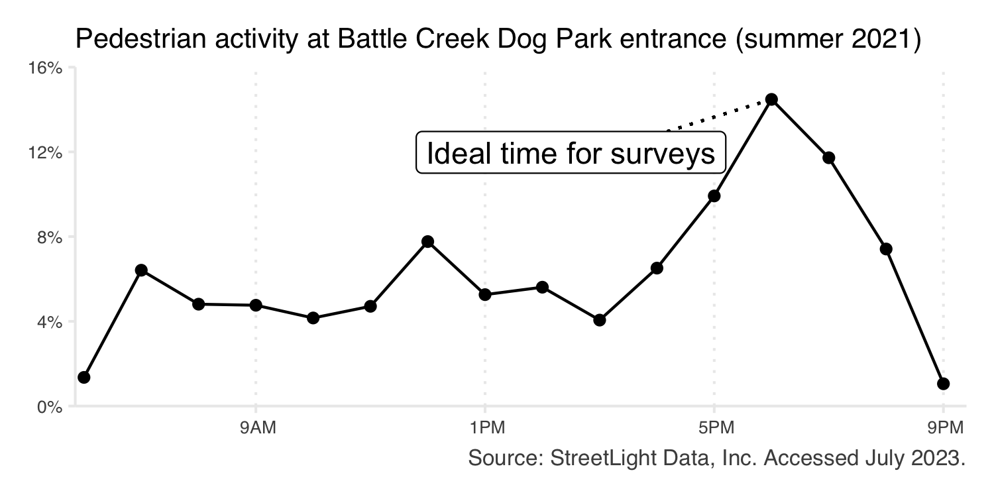

Figure 6.1: Average hourly pedestrian use at the entrance of Battle Creek Regional Park off-leash dog area (Metro Regional) during the summer of 2021.

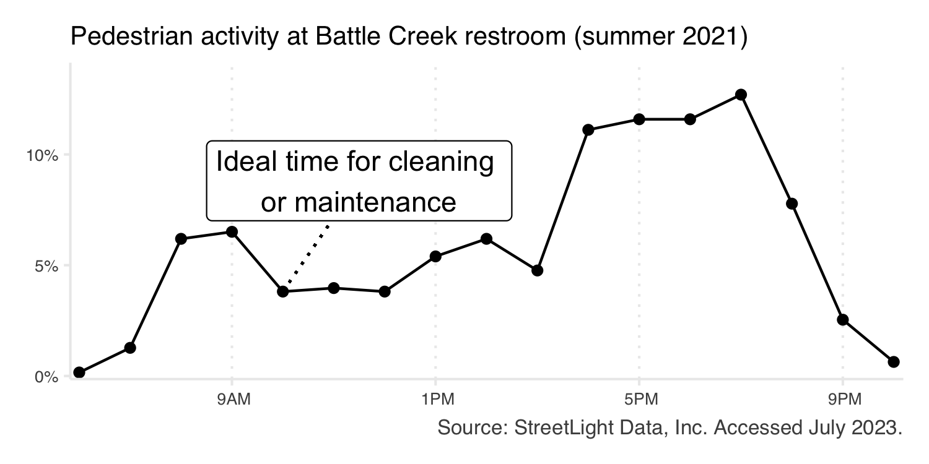

Figure 6.2: Average hourly pedestrian use near a restroom in Battle Creek Regional Park (Metro Regional) during the summer of 2021.

## 6.3 Using custom methods (requires StreetLight license)

### 6.3.1 Conduct analyses over custom geographies

The methods used for the research may be applied to new geographies. For instance, park and trail geographies may change over time or need customization beyond what was done for this research. With a StreetLight license, the code and full technical documentation used to produce this research can be applied to understand visitation patterns over custom geographies.

### 6.3.2 Hotspots of activity within a park

LBS data can be used to identify areas of high activity within a park. Specific amenities of interest can be compared, or a grid covering the entire park can be used to analyze all potential activity areas simultaneously. Such a grid can be generated using the programming language R or any Geographic Information Systems (GIS) tools.

Note that hotspots of activity on trails are already represented by the segment-level data provided.

Consider Glacial Lakes State Park (DNR). A grid of 150-meter squares was generated using R. LBS data was used to estimate the number of pedestrians passing through each grid cell on an average day during summer 2021 (Figure 6.3).

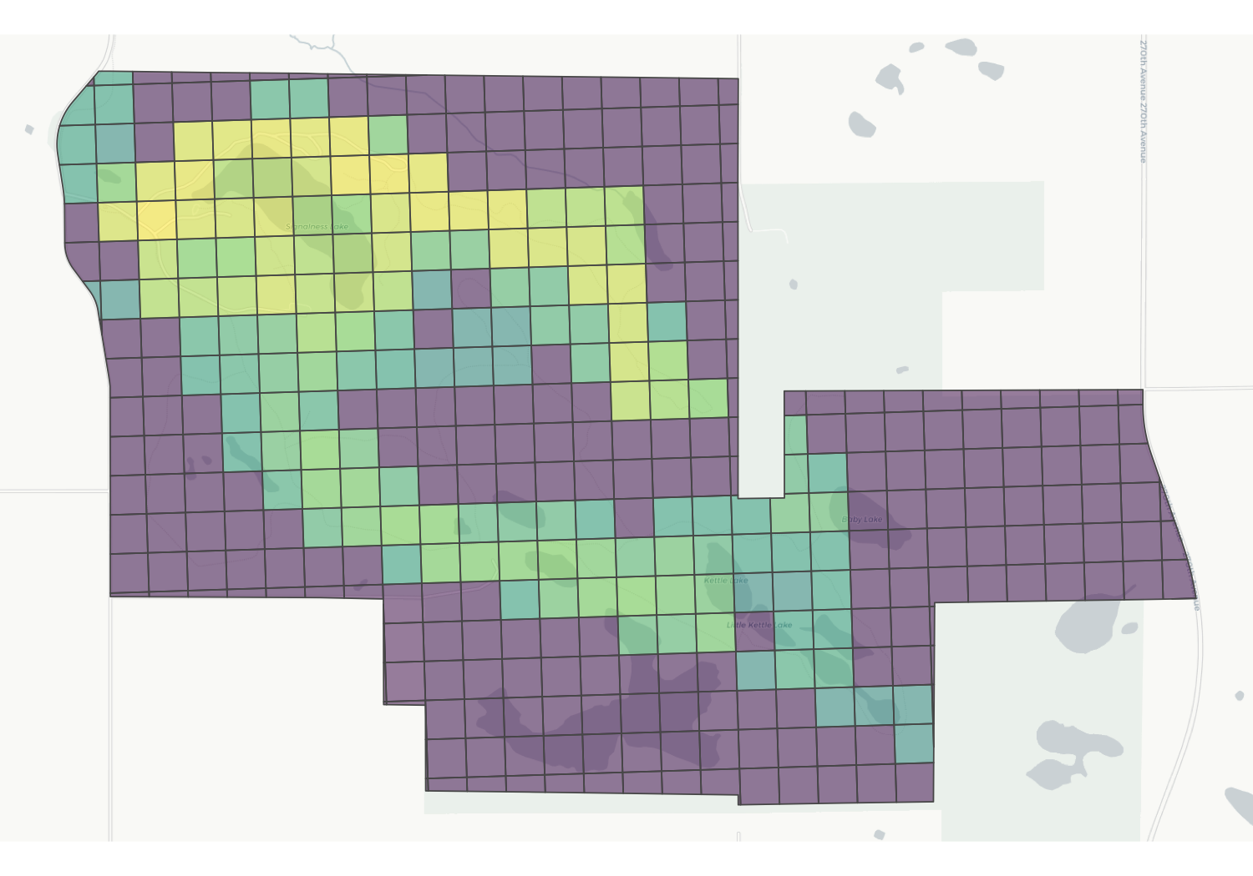

Figure 6.3: Map of pedestrian activity in 150-meter grid cells in Glacial Lakes State Park (DNR State). Activity in each grid cell is represented as a percentage of total activity across all grid cells. Activity is focused around Mountain Lake in the northwest region of the park, and along prominent trails within the park.

### 6.3.3 Trails passing through parks

When a trail passes through a park, there is some overlap between “park use” and “trail use.” Researchers might ask how many trail users stop in the park and how many simply pass through. By creating geographic gates over the points where a trail enters and exits a park, LBS data can be used to measure the proportion of trail users who stop within versus pass through the park. Registered StreetLight users can read a full tutorial [here](https://support.streetlightdata.com/hc/en-us/articles/360019499071-Create-a-cut-through-analysis-with-internal-external-gates).

Consider Hartley Park (Greater MN Regional) in Duluth. The Duluth Traverse passes through the park. Though the trail is bidirectional, we will consider bicyclists traveling north to south for simplicity. LBS data was used to measure bicyclists passing through the entrance gate during the summer of 2021. Data was summarized to determine the portion of bicyclists who stopped within the park (entrance gate to park polygon), passed through the park on the Duluth Traverse (entrance gate to exit gate), or passed through the park via some other trail connection (entrance gate to any other destination). LBS data indicates that roughly a quarter of bicyclists stop within Hartley Park, and over half connect to a different trail and exit the park elsewhere (Table 6.1).

The analysis could be expanded to consider bicyclists traveling in both directions. The same approach could be used to evaluate pedestrians or vehicles passing through parks or other geographic areas.

Table 6.1: Portion of southbound Duluth Traverse bicyclists who pass through the defined exit gate, stop in Hartley Park, or exit the park elsewhere

| Origin | Destination | Share |
| --- | --- | --- |
| Entrance Gate | Exit Gate | 18% |
| Entrance Gate | Hartley Park | 27% |
| Entrance Gate | Alternative exit | 54% |

The analysis could be expanded to consider bicyclists traveling in both directions. The same approach could be used to evaluate pedestrians or vehicles passing through parks or other geographic areas.

# 7 Recommendations and Future Work

## 7.1 Continue collaborative projects

The collaboration between Minnesota Legacy partners allowed us to leverage more information and resources than would have been possible if the project was internal to a single organization. We learned valuable information from partners at all three systems and combined collective knowledge to develop our methods. Collaboration to continue robust park and trail research that benefits all three Legacy partners should be considered in future work.

We additionally learned there is no one-size-fits-all solution for park and trail research. This project aimed to develop universal approaches for park and trail analysis, but still some bespoke solutions were necessary at the unit level. Within a park system, or even within a county or city, there may be two parks with such different qualities that different techniques are needed. For example, a park accessed primarily by vehicles may require a different approach than a park with minimal parking and extensive bike access. Due to this project’s scope, it focused on methods that apply to as many parks and trails as possible. Strategies may be improved for “edge cases,” likely with the help of park staff with detailed on-the-ground knowledge.

## 7.2 Continue exploration of novel data sources

The findings from this study were only possible due to the adoption and exploration of novel data sources (LBS data). While exploring new data sources and methods have inherent risks and challenges, the rewards may be significant.

However, no single data source can answer every research question about parks and trails. Like all data, LBS data has strengths and weaknesses. While it provides incredible spatial and temporal detail, it cannot provide information about visitor experiences or report real-time data, for example. Other data sources are needed to address such questions. LBS data may prove most insightful when combined with existing research methods.

Embracing the opportunities and challenges of novel data sources and strategies can provide impactful results. Of course, new or developing data sources have the potential to change rapidly and results from using these data sources are not guaranteed. We believe that the most robust parks research program would remain adaptable, leverage a variety of data sources, and continue experimenting with and developing new approaches.

For this project specifically, we note that industry-wide changes to the availability of LBS data have forced the data provider to discontinue providing LBS data after April 2022. While the data provider is migrating to other spatial data sources, this new data is not currently suitable for park and trail research. As such, the results from this project using LBS data should be viewed as a discrete research project which estimated visitation from January 2019 – April 2022 rather than part of a continuous (ongoing) research project. This change in availability of LBS data is emblematic of the inherit risks in using novel data sources, but the results from this project also demonstrate the rewards of exploring new data sources.

## 7.3 Connect with park staff to explore unit-level findings

Due to this project’s scope, it was impossible to connect individually with park and trail managers, staff, or researchers at each unit. However, location-based services (LBS) data allows for highly detailed analyses and applications which may be of interest to these audiences.

Significant on-the-ground knowledge about the park or trail of interest is often required for such analyses. Connecting park managers, staff, or researchers to this detailed data may allow for deeper analysis of individual units or generate more specific research questions. See Use Cases for additional examples of questions LBS data can answer.

## 7.4 Use findings to guide future work

The use of LBS data in this project has suggested several avenues for future research. In most cases, future work would not be based exclusively on LBS data. While LBS data has generated insightful results in this project, it has also clarified areas where additional work is needed to supplement LBS data or answer questions that LBS data cannot. Several potential research areas are described below.

* Interact data sources
  + LBS data showed that Minnesota’s parks and trails attract a wide range of visitors. Analysis of other data sources, such as intercept survey responses, to interact with LBS-derived visitor attributes and behavior may provide interesting results (e.g., does travel mode or distance traveled impact how visitors use parks or trails).
* Estimate vehicle multipliers (persons per vehicle)
  + One limitation of LBS data is that it cannot estimate the number of people in each vehicle arriving at a park. Therefore, a vehicle multiplier is needed to convert counts of vehicles to counts of people. This project has highlighted the need for high-quality vehicle multipliers: regardless of how vehicles are counted, vehicle multipliers are necessary to produce visitor counts. Vehicle multipliers are best estimated by survey data; this work indicates that vehicle multipliers may be a priority for future survey efforts.
  + Our data show distinct use patterns across parks and trails (e.g., weekend versus weekday peaks in use, seasonal variability, high use during special events). Vehicle multipliers may be influenced by these factors.
* Further analyze “visitation gap” and other equity questions
  + This project produced unit-level estimates of visitor’s race and ethnicity, education, and income. These inferred demographics from LBS data may compliment work aimed at understanding of inequities and barriers to accessing parks and trails for underrepresented groups. Comparing LBS demographics to bespoke reference populations at the unit level may also be useful.

# 8 Resources

## 8.1 Our partner organizations

This research was made possible by collaboration with partner organizations and Legacy Amendment funding.

* [Minnesota Legacy and Trust Funds](https://www.legacy.mn.gov/) were the source of funding for this research.
* [The Parks and Trails Legacy Advisory Committee](https://www.legacy.mn.gov/ptlac) provided guidance for this research project.
* The [Department of Natural Resources](Department%20of%20Natural%20Resources) manages state parks and trails.
* [Greater Minnesota Regional Parks and Trails Commission](https://www.gmrptcommission.org/) designates regional parks and trails in the 80 counties of Greater Minnesota.
* Metropolitan regional parks and trails are supported by the [Metropolitan Council](https://metrocouncil.org/Handbook/Plan-Elements/Parks.aspx) in partnership with [ten regional implementing agencies](https://metrocouncil.org/Parks/About/Partners.aspx).

## 8.2 Data sources

Complete methods for this research can be found in the technical documentation.

* [StreetLight Data, Inc.](https://www.streetlightdata.com/) provided anonymized and aggregated location-based services data.
* The Minnesota Geospatial Data Commons contains geography files for [DNR State parks](https://gisdata.mn.gov/dataset/bdry-dnr-lrs-prk), [DNR State trails](https://gisdata.mn.gov/dataset/trans-state-trails-minnesota), [Metro Regional parks](https://gisdata.mn.gov/dataset/us-mn-state-metc-plan-parks-regional), and [Metro Regional trails](https://gisdata.mn.gov/dataset/us-mn-state-metc-trans-regional-trails-exst-plan). Greater MN Regional park and trail files were accessed via personal communication.

## 8.3 More about Minnesota parks and trails

* [Minnesota Great Outdoors](https://mn.gov/greatoutdoors/) is another Legacy-funded collaborative project between DNR, Greater MN Regional Parks and Trails Commission, and the Metropolitan Council to provide web-based information for park and trail users.

# 9 FAQ

## 9.1 What is this project?

This exploratory research project aimed to determine the utility of location-based services (LBS) data for estimating park and trail use in Minnesota. LBS data was obtained from StreetLight Data, Inc. and was used to estimate park and trail use across three park systems: Department of Natural Resources state parks and trails (DNR state), Greater Minnesota regional parks and trails (Greater MN regional), and Twin Cities metropolitan regional parks and trails managed by ten implementing agencies in collaboration with the Metropolitan Council (Metro Regional). The project was funded with Legacy Partnership Research Funds from the State of Minnesota Parks and Trails Legacy Fund in collaboration with the three systems.

## 9.2 What is StreetLight Data?

[StreetLight Data, Inc.](https://www.streetlightdata.com/) is the provider of LBS data for this project. StreetLight purchases anonymized LBS data from third-party vendors, such as [Cuebiq](https://www.cuebiq.com/) . StreetLight then processes the data, completing quality assurance and statistical tests. The project team received aggregated and anonymized travel patterns which were used for analysis. The data vendor implements data privacy methods, and it is not possible to identify individuals or individual trips through this data source or these methods.

Broadly, LBS data is generated by GPS-enabled devices (i.e., smartphones) where users have “opted-in” to using location services. Common examples of third-party applications where users can opt in to using location services are weather, fitness, and mapping applications. Cell phone service (i.e., LTE, 3G, 4G) is not necessary for GPS functionality. StreetLight Data, Inc. uses “penetration rates” to account for incomplete adoption of GPS-enabled devices (i.e., smartphones) and users who have not opted-in to location services. StreetLight Data, Inc.’s algorithms clean the data and convert device count (i.e., sample size) into estimates of vehicles, pedestrians, and bikes which are used in this research. The LBS data provider does not explicitly measure visitors arriving by other transportation modes, but other modes (i.e., snowmobiles, boaters) may be captured and classified as either vehicle, bike, or foot visitors by the LBS data provider using their probabilistic models.

More information about StreetLight Data, Inc.’s process can be found [on their website](https://www.streetlightdata.com/).

## 9.3 What are the benefits of using LBS/StreetLight?

LBS data meaningfully complement existing park and trail use estimates (i.e., intercept surveys, manual counts, or physical trail counters). LBS data is available for parks and trails even when surveys or manual counts have not been performed. This research project processed data for all parks and trails eligible to receive Legacy funding, regardless of existing capacity for research or data collection.

Additionally, LBS data has unique strengths in providing detailed spatial and temporal information. This project produced estimates for individual parks at weekly time intervals and individual trails at monthly time intervals. Data is available for January 2019 - April 2022.

Please note that there are many park and trail research methods. Each has benefits and drawbacks; LBS data is not the appropriate tool for all research questions.

## 9.4 What can we measure?

The LBS data used in this project includes estimated counts of vehicles, bicyclists, and pedestrians. We must apply a vehicle multiplier (average number of persons per vehicle) to convert vehicle counts to visitor counts. These counts are combined to estimate of total use at each park and trail.

This data is available in monthly time intervals for trails and weekly time intervals for parks, allowing for detailed time series trend analyses.

Visitor demographics are inferred based on census data. While inferred demographics are informative, they are different than intercept surveyed responses and cannot capture visitors’ lived experiences.

The LBS data provider does not explicitly measure visitors arriving by other transportation modes, but other modes (i.e., snowmobiles, boats, equestrians, skiers) may be captured and classified as either vehicles, bikers or walkers by the LBS data provider using their probabilistic models. It cannot identify unique versus repeat visitors, nor can it measure how long visitors spend at a park or trail. Devices registered to minors (under age 18) are not included in the LBS data source.

## 9.5 How were vehicle multipliers determined?

For Metro Regional parks, agency-level vehicle multipliers ranging between 1.71 and 2.72 were applied. State parks use a vehicle multiplier of 3.2 based on current DNR practices. We recommend 2.46 as a baseline vehicle multiplier for Greater Minnesota Regional parks. This is the average of the suburban Metro Regional agency multipliers and the DNR State park multiplier.

## 9.6 Why don’t park boundaries match official park boundaries?

Park boundaries were edited to remove unrelated roads in order to isolate park visitors. In some cases, boundaries were expanded to include lake or river shores or amenities, such as trailheads and parking lots, that fell outside of original park boundaries. In many cases, boundaries were edited based on feedback requested throughout the project. Park and trail boundaries, in addition the number of parks and trails, remained constant over the course of this study (January 2019 – April 2022).

## 9.7 Why don’t trail segments match official trail alignments?

This can happen for several reasons. Very short segments, or segments which are primarily highways, may be excluded on purpose. Otherwise, differences between trail alignments and segments are explained by OpenStreetMap data availability. In some cases, when trails run alongside roads, the best OSM match will include a longer section of road than appropriate. In other cases, the trail simply isn’t represented in OSM data. This is most common for trails still under development or for short sections or spurs.

Trail geographies were edited based on provided shapefiles and maps available via respective agency websites, OpenStreetMap, and sources such as Minnesota Great Outdoors, AllTrails, etc. Revisions to OpenStreetMap data are beyond the scope of this project.

## 9.8 How does this project affect my park/trail?

Data from this project is intended to supplement existing data. All partners have assisted in funding this research project, but the data from this project is not linked to funding allocation.

## 9.9 What’s next with StreetLight?

Recent industry-wide changes to the availability of location-based services (LBS) data have forced StreetLight, and other data providers, to adopt new data sources and strategies. As of May 2022, LBS data is no longer available. Other data sources that StreetLight and other providers are migrating to are not suitable for park and trail research at this time.

## 9.10 What’s next for this project?

We recommend using the findings from this work to guide other research until the future of LBS data is more clear. For example, these results may be used to refine existing research questions. Please view the “Recommendations and Future Work” and “Use Case” sections for more detail. At this time, the results from this project using LBS data should be viewed as a discrete research project which estimated visitation from January 2019 – April 2022 rather than part of a continuous (ongoing) research project.